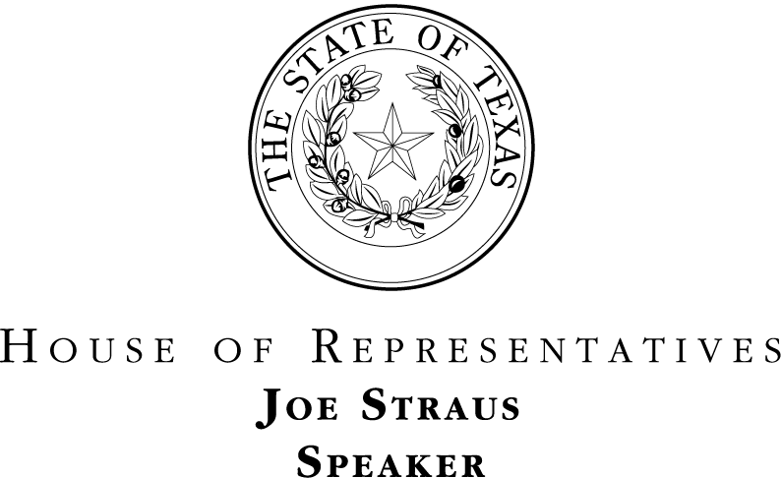

December 20, 2013

Dear Board Member,

I recently became aware of Governor Perry's November 22 letter to executive branch appointees regarding oversight responsibilities. I am writing to agree with and expand upon Governor Perry's comments on the importance of appropriate oversight.

Oversight of state agencies and institutions was never meant to be comfortable or easy. Members of the Legislature share with you the burden and the difficult task of overseeing agencies whose charges include teaching our children, paving our roads, and keeping us safe. While your oversight comes in the form of board action, the Legislature's oversight comes in two forms -- the normal legislative committee review process (including our review of an agency or institution during the appropriations process) and the examination of an agency or institution when a particular alarm is raised by the governing board or the public.

To paraphrase Governor Perry, Texans should be deeply troubled when an entity with oversight authority is stymied from exercising that authority. I am proud of the fact that not a single board member or employee of an agency has ever appeared before a legislative oversight committee and refused to answer questions about either their actions or an agency’s operation. Both board members and the Legislature need to ask difficult questions. This is why the House, after discussions with the Governor, created the Select Committee on Transparency in State Agency Operations: so that we do not have to choose between preserving the efficient operation of state government and drawing a veil of secrecy around agency operations.

Recent experience indicates that only the combination of effective legislative oversight and the oversight provided by appointed boards helps keep this state headed in the right direction. In the last two budget cycles, your suggestions allowed Texans to receive essential services during challenging budget times. By working cooperatively with legislators on a number of bills, and by providing invaluable expert testimony, you helped the Legislature reform state agencies to make them more responsive to Texas taxpayers.

In spite of the large number of successes, some high-profile incidents underscore the need for legislative oversight:

- In the past session, the work of the Transparency Committee highlighted inefficiencies, including failures of the governing board, at CPRIT. The legislative review led to the replacement of the entire board and criminal charges against former employees.

- The failure of appointed board members at the Texas Youth Commission to deal with issues brought to light by legislative oversight committees led to the wholesale departure of the board, the placement of the agency into conservatorship, and the eventual dissolution of the agency.

- Oversight failures by individual members of the board or the board itself have also led to needed board changes at the Texas Department of Housing and Community Affairs, the Texas Lottery Commission, and UTIMCO.

It is important to note that ethical lapses and public corruption by state agencies are neither common nor tolerated in Texas. As Texans, we have had a deserved reputation for operating an efficient, appropriately sized government which meets citizens’ needs. However, when problems arise, taxpayers expect the Legislature to ask questions, identify areas for improvement, and enact reforms.

As House committees begin to work on their interim charges and visit with agencies about their priorities, I urge both House members and executive appointees to work together to identify items that may be appropriate to investigate, remedy, or eliminate. Only by the executive and legislative branches appropriately exercising their oversight powers can the public be assured that each taxpayer is getting the maximum benefit from state government.

Finally, the Governor expressed that some appointees wonder, based on questions now being asked by the House Committee on Transparency in State Agency Operations, if they should limit their oversight roles. The House does not seek to limit oversight. Rather, the House wants effective and appropriate oversight that allows agencies to operate properly and efficiently. On the rare occasion that executive appointees appear to be using their authority to harm the agencies they oversee, the Legislature will continue to exercise its own oversight responsibilities.

Thank you for your service to Texas and for your partnership with the Texas Legislature. Our joint work makes us a model for the rest of the county.
Sincerely,

Joe Straus
Speaker

JRS/je

cc: The Honorable Rick Perry, Governor
The Honorable David Dewhurst, Lieutenant Governor
Members, 83rd Texas Legislature

